Smart Outdoor Lights

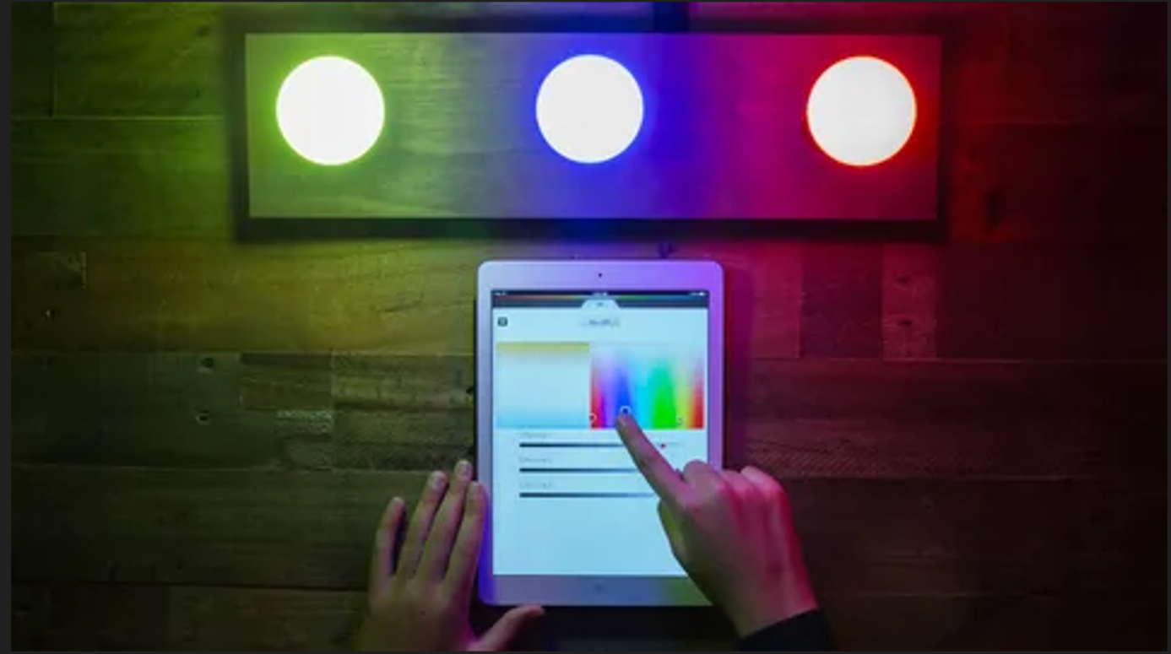

#### ****Description:****

**Smart Outdoor Lights** are advanced, weather-resistant lighting solutions designed to enhance the security and ambiance of your outdoor spaces. These lights integrate seamlessly with your smart home ecosystem, offering features like motion detection, scheduling, and remote control. Perfect for gardens, patios, driveways, and more, Smart Outdoor Lights provide both functionality and style.

* **Technology:** Wi-Fi, Bluetooth, or Zigbee (depending on the model).
* **Compatibility:** Works with iOS and Android devices.
* **Bulb Type:** Integrated LED (non-replaceable).
* **Wattage:** 15W (equivalent to 100W incandescent).
* **Lumens:** 1200 lumens.
* **Color Options:** Adjustable white light (2200K-6500K) + 16 million colors (for RGB models).
* **Dimmable:** Yes.
* **Lifespan:** 50,000 hours.
* **Energy Efficiency:** Energy Star certified.
* **Control Options:** Mobile app, voice control (Alexa, Google Assistant, Apple HomeKit).
* **Weather Resistance:** IP65 rated (dust-tight and protected against water jets).

#### ****Key Features:****

* **Motion Detection:** Automatically turns on when motion is detected, enhancing security.
* **Customizable Lighting:** Adjust brightness and color to create the perfect ambiance.
* **Voice Control:** Compatible with Alexa, Google Assistant, and Apple HomeKit for hands-free control.
* **Energy-Efficient:** Uses up to 85% less energy than traditional incandescent bulbs.
* **Scheduling and Automation:** Set schedules, timers, and routines for automated lighting control.
* **Group Control:** Control multiple lights simultaneously for synchronized lighting.
* **Easy Installation:** Designed for simple outdoor mounting with included hardware.
* **Modern Design:** Sleek and stylish, suitable for any outdoor decor.

#### ****Pricing:****

* **Single Light:** $89.99
* **2-Pack:** 159.99(159.99(80.00 per light)
* **4-Pack:** 299.99(299.99(75.00 per light)

#### ****Where to Use:****

* **Gardens:** Create a cozy or vibrant atmosphere with customizable colors.
* **Patios:** Set the perfect lighting for outdoor gatherings.
* **Driveways:** Enhance security with motion-activated lighting.
* **Pathways:** Provide consistent and energy-efficient lighting.
* **Porches:** Brighten up entryways with adjustable white light.

### ****Customer Reviews:****

* ⭐⭐⭐⭐⭐ "These Smart Outdoor Lights are amazing! They were super easy to install, and I love controlling them with my phone. The motion detection feature is a great addition for security." – Sarah L.
* ⭐⭐⭐⭐ "Great value for the price. The lights are bright, and the app is easy to use. Highly recommend for anyone looking to upgrade their outdoor lighting." – James T.
* ⭐⭐⭐⭐⭐ "I love how energy-efficient these lights are. The scheduling feature is a game-changer for my daily routine." – Emily R.

### ****How to Order:****

1. Visit our website: [www.brightworldlighting.com](http://www.brightworldlighting.com/)
2. Select your preferred pack size (Single, 2-Pack, or 4-Pack).
3. Add to cart and proceed to checkout.
4. Enjoy free shipping on all orders over $100!

### ****Warranty and Support:****

* **Warranty:** 2-year limited warranty covering manufacturing defects.
* **Customer Support:** Contact us at [support@brightworldlighting.com](mailto:support@brightworldlighting.com) or call +1-800-123-4567 for assistance.

### ****Visual Representation:****

Include high-quality images of the Smart Outdoor Lights in different settings (e.g., garden, patio) to showcase their versatility and design.